**Lab Project Submission**

submitted for

**Software Engineering (UCS503)**

**Calorie-Click: Total Nutritional Calculator**

submitted by

**Aryan Garg 102103768**

**Samarth Paliwal 102103775**

**3 COE 27**

submitted to

**Dr. Nitigya Sambyal**



Computer Science and Engineering Department

Thapar Institute of Engineering and Technology, Patiala

**Software Bid/ Project Teams**

**UCS 503- Software Engineering Lab**

Group: 3Co27 Dated: 29 August 2023

**Team Name: O554**

**Team ID: 7**

Please enter the names of your Preferred Team Members:

· You are required to form **a three to four person** teams’

· Choose your team members wisely. You will not be allowed to change teams.

|  |  |  |  |  |
| --- | --- | --- | --- | --- |
| Name | Roll No | Project Experience | Programming Language used | Signature |
| Aryan Garg | 102103768 | RNN Based Story Generator, Full Stack Data Engineering | Python |  |
| Samarth Paliwal | 102103775 | Hop Shop Ecommerce Store, News Website | ReactJs, Node, MongoDB,Express,Python |  |

**Programming Language / Environment Experience**

List the languages you are most comfortable developing in, **as a team**, in your order of preference. Many of the projects involve Java or C/C++ programming.

1. Python

2. JavaScript

**Choices of Projects:**

Please select **4 projects** your team would like to work on, by order of preference:

|  |  |
| --- | --- |
| First Choice | Image Based Calories and Macro Nutrients tracker Webapp |
| Second Choice | AI based News delivery Webapp |
| Third Choice | Ham Spam classifying Chrome Extension |
| Fourth Choice | Parking validator using image Processing |

**Additional Remarks/ Inputs**

Please tell us about any other factors that we should take into consideration (e.g., if you really would like to work on a project for some particularly convincing reason).

We believe that we can work on this project with ease and will be ale to do justice to the problem statement with our relevant skill set. **__________________________________**

**_______________________________________________________________________**

**TABLE OF CONTENTS**

# Chapter No. Topic Page No.

|  |  |  |  |  |
| --- | --- | --- | --- | --- |
| 1. |  |  | Introduction | 5 |
|  | 1.1 |  | Purpose of this Document | 5 |
|  | 1.2 |  | Scope of the Development Project | 5 |
|  | 1.3 |  | Definitions, abbreviations and acronyms | 6 |
|  | 1.4 |  | References | 7 |
|  | 1.5 |  | Overview | 7 |
| 2. |  |  | Overall Description | 8 |
|  | 2.1 |  | Product Perspective | 9 |
|  | 2.2 |  | Product functions | 9 |
|  | 2.3 |  | User Characteristics | 9 |
|  | 2.4 |  | General Constraints, Assumptions and Dependencies | 10 |
|  | 2.5 |  | Apportioning of the requirements | 10 |
| 3. |  |  | Specific Requirements | 11 |
|  | 3.1 |  | External Interface Requirements | 11 |
|  | 3.2 |  | Detailed Description of Functional Requirements | 11 |
|  |  | 3.2.1 | Functional Requirements for Log-in Screen | 12 |
|  | 3.3 | 3.2.2  3.2.3 | Functional Requirements for Upload Image Screen  Functional Requirements for Statistics Page  Performance requirements | 12  12  13 |

1. Document Approvers 14

# 1.Introduction

## **Purpose of this Document**

The purpose of this SRS document is to provide a detailed overview of our software product, its parameters, and goals. This document describes the project's target audience, the problem it solves and its user interface, hardware, and software requirements. **It defines how our client, team and audience see the product and its functionality.**

* 1. **Scope of the Development Project**

The goal is to design software which can detect various food items on the predictions of a pre-trained ML model and generate nutritional information about them. In this system, a user will upload images of their food to perform scan on the image provided. The Deep Learning model will study the image and detect the class of food it is. (Which is upto 20 classes). From this, we can extract nutritional information about the food from our static database and add it into our system for further charting. The user can further graph the information and look ath their habits developed over a span of a day, a week or even a month. All the details of the user, their images and statistics made will be stored in database server and will also be replicated in a backup server daily to avoid data loss. The ML model will be updated time to time to increase the accuracy of prediction model.

The software must be able to perform the following operations:

**1. Identify and authenticate the actor:** It must be able to authenticate the user logging in the system, where each user has its own confidential information and where they can log their own stats.

**2. Scan and predict the correct meal:** The software must be able to scan the uploaded images and predict the meal correctly based on the training data and classifications applied on the pretrained model.

**3. Generate Statistical Graphs:** The software will generate nutritional information about the meal. It should atleast contain the minimal nutritional information that we are accustomed to, like calories, protein, and fiber.

**6. Update ML model when required:** The software should provide the admin access to update the ML prediction model as and when required to increase the accuracy of predictions. It must authenticate the admin before allowing updating rights.

Initially we plan to implement these functionalities on 10 food items as a part of the **Pilot Phase** to check the authenticity and accuracy of our model on new set of images. After the successful completion of the pilot phase, we plan to make this software publicly available for everyone, with more food items added. In the **Third Phase** we plan to integrate more food items, and instead of creating this as a classification problem, we may treat this as a regressive problem to find the calories in ANY food item, irrespective its data is present in the database.

This will help the users who need specific nutritional needs by allowing them to easily look into their meals and keep a track of their daily intake. Slowly as the accuracy of the model increases, this software can be of great help to all the users to identify all types of food.

* 1. **Definitions, abbreviations, and acronyms**

**Definitions**

Table 1 gives explanation of the most used terms in this SRS document.

**Table 1: Definitions for most used terms**

|  |  |  |
| --- | --- | --- |
| **S.No.** | **Term** | **Definition** |
| **1** | Machine Learning | Machine learning is a branch of [artificial intelligence (AI)](https://www.ibm.com/topics/artificial-intelligence) and computer science which focuses on the use of data and algorithms to imitate the way that humans learn, gradually improving its accuracy. [1] |
| **2** | Pre-Trained model | A pre-trained model is a saved network that was previously trained on a large dataset, typically on a large-scale image-classification task. [2] |
| **3** | CNN | A convolutional Neural Network, is a machine learning model, that uses convolutions to help process images. [3] |
| **4** | Authentication | A user authentication policy is a process in which you verify that someone who is attempting to access services and applications is who they claim to be. [4] |

* 1. **References**

[1] **Machine Learning, LINK:** [**https://www.ibm.com/topics/machine-learning**](https://www.ibm.com/topics/machine-learning)

[2]**Pre-Trained model, LINK:** [**https://www.tensorflow.org/tutorials/images/transfer_learning**](https://www.tensorflow.org/tutorials/images/transfer_learning)

[3]**CNN, LINK:** [**https://www.techtarget.com/searchenterpriseai/definition/convolutional-neural-network**](https://www.techtarget.com/searchenterpriseai/definition/convolutional-neural-network)

[4]**Authentication, LINK:** [**https://www.cisco.com/c/en/us/products/security/identity-services-engine/what-is-user-authentication-policy.html**](https://www.cisco.com/c/en/us/products/security/identity-services-engine/what-is-user-authentication-policy.html)

**1.5 Overview**

The remaining sections of this document provide a general description, including characteristics of the users of this project, the product's hardware, and the functional and data requirements of the product. General description of the project is discussed in section 2 of this document. Section 2 gives the functional requirements, data requirements and constraints and assumptions made while designing the multi-utility system. It also gives the user viewpoint of product use. Section 3 gives the specific requirements of the product. Section 3.0 also discusses the external interface requirements and gives detailed description of functional requirements

1. **Overall Description**
   1. **Product Perspective**

The software will run as website which can be accessed by users. The user is supposed to upload the meal images to know the nutritional information of their meal.

Here the user will have to login using the registered credentials. When any user tries to login their login credentials are matched with the already saved data in the user database. If the credentials match the user is logged in, while a message appears whenever the credentials are incorrect.

After the authentication process, the Meal Detection software has 2 more modules:

1. Upload Image/Capture Image
2. Meal Statistics
3. User Manual

Once the user is **authenticated**, they can upload the image of their meal to the software. The ML model running in the backend of the product takes the image as input and performs the specified tasks. The model then predicts the meal according to the pre-trained sets and gives and output to the system.

Once the output is generated by the model, the system then **meal specific statistics** which contains all the necessary information about the meal (Calories, fiber, protein etc.). This published and can be viewed by the user. The same report gets stored in the user database for future reference.

In addition to the two modules, a **Central database server** and a **Backup database server** will also be used in order to read/write data onto the repository. The central database server will periodically update the Backup database server so that in case of server failure it can restore the data by retrieving the records stored in the Backup database server’s tables.

* 1. **Product Functions**

The product should be able to perform the following operations**:**

1. It must be able to authenticate the user by matching the Username and Password which is created at the time of registration and stored in the database.
2. The system should provide appropriate access rights to the user according to the role of the user.
3. The software must allow the user to upload images of the food image and should predict the disorder accurately using the pre-trained ML model.
4. It must provide the user with a detailed statistical information about the meal and provide all the required information including Calories, protein, fiber.
5. It must provide the admin the right to update the ML model as and when needed to improve the accuracy of data prediction.
   1. **User Characteristics**

The goal is to design software for meal detection using ML and providing users check the calorific values of meals. These user types are listed below as follows:

1. General User
2. Admin/ Developer

As one can see that the users can belong to various socio-economic lifestyles, and we plan to create a platform that is inclusive to everyone. The users should at least have some technical knowledge which include:

* The user has the ability to take photos on the website, either by using their phone, or uploading them later on another device
* The user has a direct connection with the internet at a minimal speed of at least 0.5 MBPS.
  1. **General Constraints, Assumptions and Dependencies**

The following list presents the constraints, assumptions, dependencies, or guidelines that are imposed upon implementation of the Meal Detection System:

* As images of high resolution will be uploaded by user the system and the model should be ready enough to process these images
* There are no memory requirements
* The product must have a user-friendly interface that is simple enough for all types of users to understand.
* Response time for loading the software and for processing a transaction should be no longer than 10 seconds.
* A general knowledge of basic computer skills is required to use the product.
* Strong Authentication and Encryption techniques are required to keep the data secure from any user data leak.
* The central database server and backup database servers should be updated regularly. This updating and replication of data from central database server to the backup database server can introduce additional latency in the working of the system.
* The replication of data from central to the backup server has to be Asynchronous as it also provides a greater amount of protection by extending the distance between the primary and secondary locations of the data. Increased distances can provide protection from local events as the loss of a power grid, as well as natural disasters such as earthquakes and hurricanes.
  1. **Apportioning of requirements**

The Meal nutrition Detection is to be implemented in the following three phases:

1. **Pilot Phase:** Here the meal nutrition detection system will be first tested on images collected from the internet as well as from friends and family to maintain the accuracy of thepre-trained MLmodel. This will help us ensure that the model is not providing any wrong predictions.
2. **Public Awareness:** Following the successful completion of the pilot phase, we plan to make this software available for the use of public first. This will give them the general idea of the new technology to detect food items from images and give detailed information about their nutrients.
3. **Adding Additional Food Items:** Following the general like towards the product, we can add new food categories to increase the usability of the product.
4. **Specific Requirements**
   1. **External Interface Requirements**

The following list represents the external interface requirements:

* **User Interface**: The app should have a user-friendly interface to capture food photos. It should also display the predicted calorie count and any additional relevant information to users.
* **Camera Integration**: The app should have access to the device's camera to capture food images. Integration with the camera API on both mobile and desktop z platforms is essential
* **Calorie Database**: Access to an external calorie database or API to retrieve nutritional information for various food items. This database should be regularly updated and accurate.
* Security of user data is a big feature the software should be capable of handling.
* As such no hardware devices are required for the software but can later be integrated with the development in the project.
  1. **Detailed Description of Functional Requirements**

Table 3 shows a template that we’ll be using to describe functional requirements for two users, General User and Admin/Developer

**Table 3: Template for describing functional requirements**

|  |  |
| --- | --- |
| **Purpose** | A description of the functional requirements and its reasons |
| **Inputs** | What are the inputs; in what form will they arrive; from what sources  can the inputs come; what are the legal domains of each input. |
| **Processing** | Describes the outcome rather than the implementation; includes any  validity checks on the data, exact timing of operation (if needed), how to handle unexpected or abnormal situations |
| **Outputs** | The form, shape, destination, and volume of output; output timing; range of parameters in the output; unit of measure of the output; process by which output is stored or destroyed; process for handling  error message produced as output. |

**3.2.1 Functional Requirements for Log-in Screen**

|  |  |
| --- | --- |
| **Purpose** | To authenticate users, and validate their credentials |
| **Inputs** | UserID, Password |
| **Processing** | The ID and password are sent to the database and compared with the stored value. When validated users are directed to the home screen. On failure the process is repeated |
| **Outputs** | The user is logged in to the account |

**3.2.2 Functional Requirements for Food Upload Page**

|  |  |
| --- | --- |
| **Purpose** | To upload Food Image |
| **Inputs** | Image of Food on the device, can also take a photo on the spot with a camera. |
| **Processing** | The food image is fed into the pre-trained ML model. The model evaluates the image based on training data and determines which class the food belongs to (top 3) |
| **Outputs** | The page determines which food the class belongs to (Top 3) |

**3.2.3 Functional Requirements for Statistics Page**

|  |  |
| --- | --- |
| **Purpose** | To check food logs |
| **Inputs** | None |
| **Processing** | Process previous data and generate meaningful data to the end user |
| **Outputs** | Tables or graphs of the food consumed |

* 1. **Performance Requirements**
* The software is designed as a website and can run from a standalone desktop PC.
* The software will support simultaneous user access only if there are multiple-terminals.
* For normal conditions, 95% of the transactions should be processed in less than 10 seconds.

1. **Document Approvers**

SRS for Calorie Click: Image Based food recognition and nutrient information web-app approved by: ___________________

Designation:

Date:

**Feasibility Report**

**Project Overview:**

The "Calorie Click" project aims to revolutionize the way individuals access nutritional information by leveraging image recognition technology. The primary objective is to develop a user-friendly website that allows users to obtain detailed nutritional information about food items simply by capturing a photo.

**Technical Feasibility:**

• **Technical Expertise**: Our team possesses the necessary technical expertise in Web Development, Machine Learning and Database Management.

• **Technology Stack**: We plan to use industry-standard web development technologies such as HTML, CSS, JavaScript, ML Models like CNN, and a backend framework.

• **Infrastructure**: We will need dedicated servers or cloud hosting to handle system scalability and performance requirements.

• **Data Privacy and Security**: Address data privacy and security concerns, including compliance with relevant regulations.

**Operational Feasibility:**

• **User Acceptance**: Data will be tested on dataset to achieve the best accuracy.

• **Consultants Support**: Engaging with a multidisciplinary team of consultants, including machine learning specialists, medical experts, and regulatory advisors, to ensure comprehensive support for developing the Automated Meal detection system.

• **Resource Availability**: Necessary resources, including personnel and technology, are available or can be acquired within the project timeline.

**Economic Feasibility:**

• **Cost Estimation**: The project will require initial investments in software development, machine learning model development, and data acquisition. Ongoing operational costs include maintenance, cloud computing expenses, and potential personnel costs. A detailed budget analysis is necessary to determine the economic feasibility.

**Scheduling Feasibility**:

• **Project Timeline**: The project timeline is reasonable, with development, testing, and deployment expected to take approximately 2-3 months for the website along with a working model, and require 9-12 months for full implementation.

• **Resource Allocation**: Resources, including human resources and technology

infrastructure, can be allocated according to the project timeline.

**Legal Feasibility**:

• **Regulatory Compliance**: The project will adhere to all relevant data protection

regulations (e.g.,GDPR)

**Security Feasibility:**

* **Secured Software:** The project will apply SHA256 encryption to hash and save the passwords.

**Cultural Feasibility**:

• **Diverse Cultural Data**: Collecting a wide range of cultural data to avoid biases and stereotypes.

• **User Preferences**: Allowing users to self-identify their cultural backgrounds and preferences to ensure personalized

• **Ethical Guidelines**: Adhering to ethical guidelines and involving cultural experts in the development process to avoid cultural insensitivity.

**Conclusion**:

The development of Calorie Click (Meal Tracking System) is technically and economically feasible. However, it requires substantial data, technical expertise, and financial resources. Ensuring data privacy and security, scalability, and user adoption will be key operational challenges. By addressing these challenges and maintaining a focus on building credibility, the system can provide accurate predictions based on calorific values, enhancing our authenticity.

**GAANT CHART**

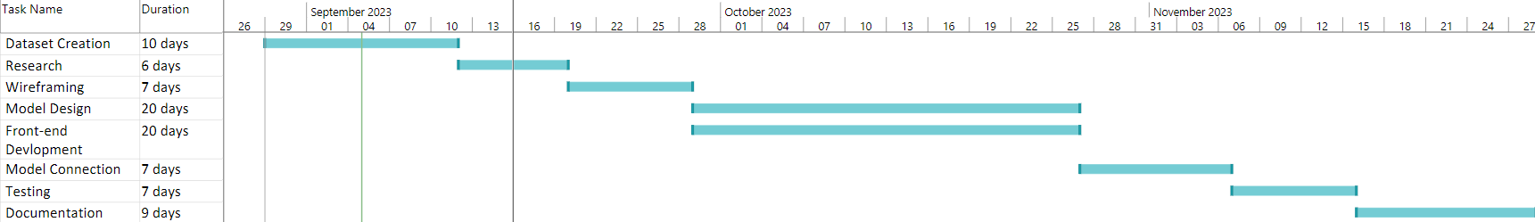

**Use Case Diagram**

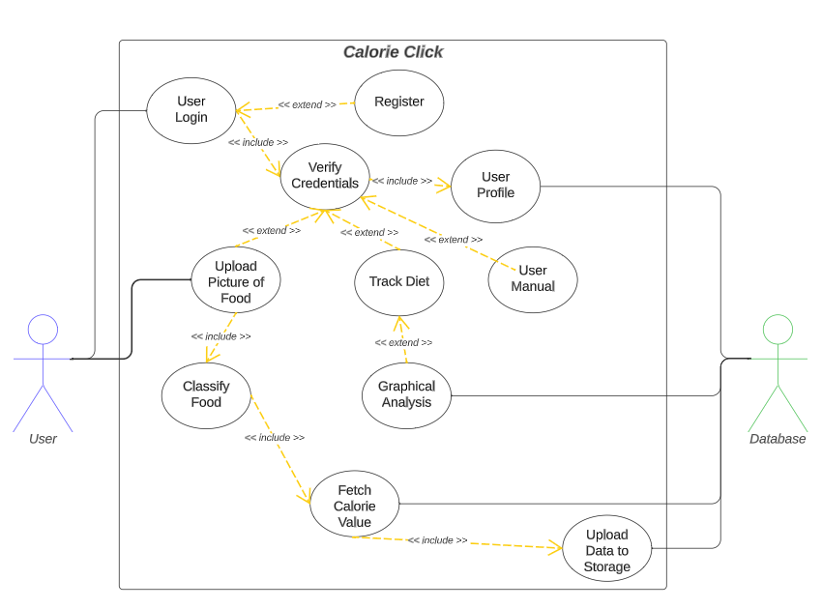

**Use Case Template**

|  |  |
| --- | --- |
| 1. Use Case Title | User Login |
| 2. Abbreviated Title | User Login |
| 3. Use Case ID | 1 |
| 4. Actors | User |
| 5. Description: Login by filling in user name and password to access the software. | |
| 5.1. Pre-Conditions: User must be signed up and verified | |
| 5.2. Task Sequence:   * Enter username * Enter set user password. * Verify by clicking on “Log In”. | |
| 5.3. Post Conditions: User is logged in and can now access the software. | |
| 6. Modification History: Date 17-September-2023 | |
| 7. Author: Aryan, Samarth | |

|  |  |
| --- | --- |
| 1. Use Case Title | Upload/Capture Food Image |
| 2. Abbreviated Title | Upload/Capture Picture of Food |
| 3. Use Case ID | 2 |
| 4. Actors | User |
| 5. Description: User can upload any food item image to log his food intake. | |
| 5.1. Pre-Conditions: User must be logged in to the software. | |
| 5.2. Task Sequence:   * Click on ‘Upload Image/capture Image’ to upload an image. * Click on ‘Submit’ button. | |
| 5.3. Post Conditions: User will see a preview of image he uploaded/captured. | |
| 6. Modification History: Date 17-September-2023 | |
| 7. Author: Aryan, Samarth | |

|  |  |
| --- | --- |
| 1. Use Case Title | Choosing the appropriate food |
| 2. Abbreviated Title | Choosing the most appropriate food item predicted by ML model |
| 3. Use Case ID | 3 |
| 4. Actors | User |
| 5. Description: User will see a popup after clicking on ‘submit’ button and will choose the most appropriate food item from three options provided by ML model | |
| 5.1. Pre-Conditions: User must be logged in to the software. | |
| 5.2. Task Sequence:   * Choosing the best suited predicted food item of image he/she submitted. | |
| 5.3. Post Conditions: Chosen food item will be logged in database. | |

|  |  |
| --- | --- |
| 1. Use Case Title | Full Day Diet Nutrient log |
| 2. Abbreviated Title | Track Diet |
| 3. Use Case ID | 4 |
| 4. Actors | User |
| 5. Description:  The user can review their entire day's dietary intake, including an analysis of various nutrients consumed, to determine whether they have met their daily nutritional requirements. | |
| 5.1. Pre-Conditions:   * User must have an active account and must be logged in. | |
| 5.2. Task Sequence:   * User need to click on “Nutrient Log”. | |
| 5.3. Post Conditions:  The user will receive nutritional information for their different meals. | |
| 6. Modification History: Date 17-September-2023 | |
| 7. Author: Aryan, Samarth | |

|  |  |
| --- | --- |
| 1. Use Case Title | User Manual |
| 2. Abbreviated Title | Information |
| 3. Use Case ID | 5 |
| 4. Actors | User |
| 5. Description: Users can learn how to use the software | |
| 5.1. Pre-Conditions: User must be logged in to the software. | |
| 5.2. Task Sequence:   * Click on “User Manual” button | |
| 5.3. Post Conditions: User will get Information about how the website works | |
| 6. Modification History: Date 17-September-2023 | |
| 7. Author: Aryan, Samarth | |

|  |  |
| --- | --- |
| 1. Use Case Title | User Logout |
| 2. Abbreviated Title | User Logout |
| 3. Use Case ID | 6 |
| 4. Actors | User |
| 5. Description: Logout by pressing logout button | |
| 5.1. Pre-Conditions: User must be logged in | |
| 5.2. Task Sequence:   * Press Logout Button | |
| 5.3. Post Conditions: User is logged out from the software | |
| 6. Modification History: Date 17-September-2023 | |
| 7. Author: Aryan, Samarth | |

**Activity Diagram**

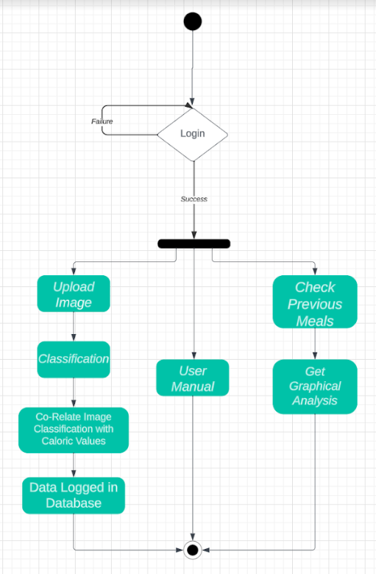

**Swimlane**

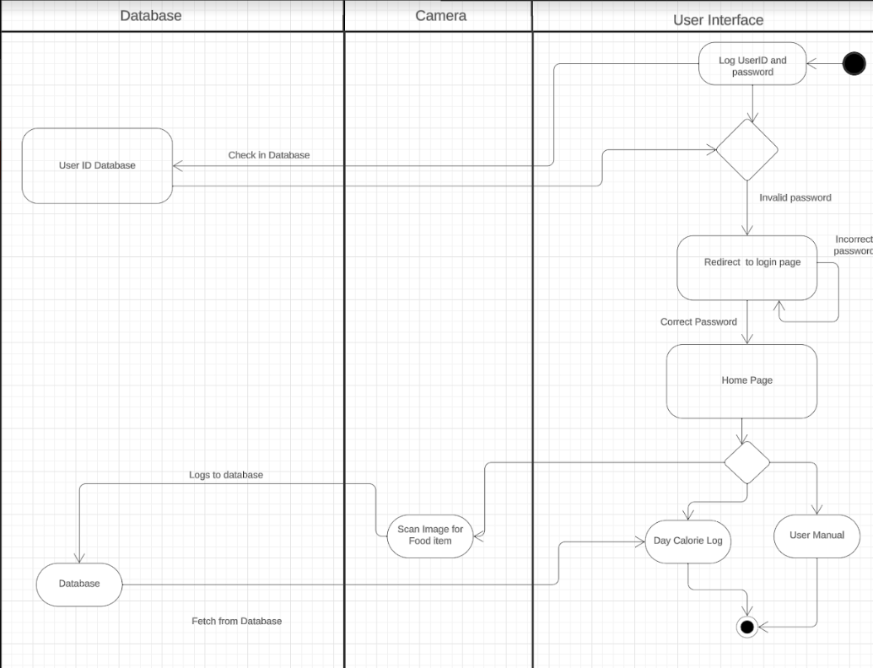

**Data Flow Diagram-0**

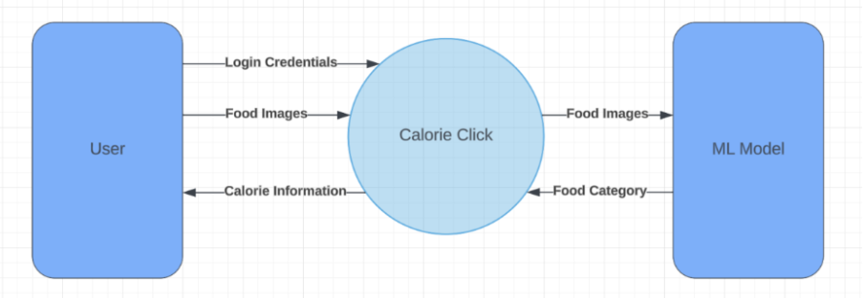

**Data Flow Diagram-1**

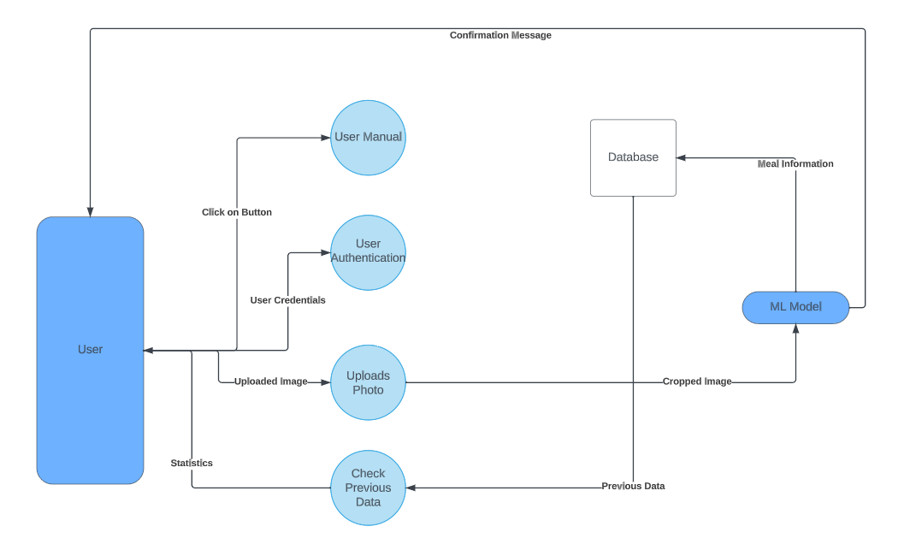

**Data Flow Diagram-2**

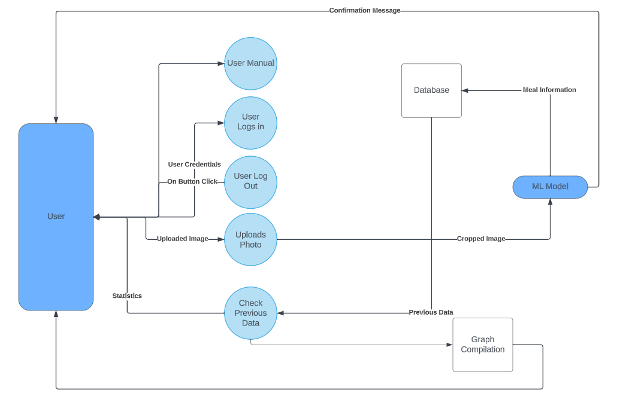

|  |  |  |
| --- | --- | --- |
| #001 | User Login |  |
| As a [registered user], I want to [login], so I can [access my nutritional information] | | |
| Authentication against  JWT Service | Error Messages (if any) |  |

UserID: Validate Format

|  |
| --- |
| **Confirmation (Login):**   1. **Success:** valid user logged in and directed to home page. 2. **Failure:** display message   a. “Something Went Wrong” in case where Username or Password is missing |

|  |  |  |
| --- | --- | --- |
| #002 | Capturing/Uploading Meal Image |  |
| As a [logged in user], I want to [add a meal], so that I can [track my diet] | | |
|  | Image Preview (After Capture/ Upload)  Submit Image to AI Model  Upload Image from System Memory  Capture Image from Webcam |  |

|  |
| --- |
| **Confirmation (Image):**   1. **Success:** Preview of food image is available on home screen. 2. **Upload image button clicked:** Upload image dialog box is opened. 3. **Capture image button clicked:** Uploading image via webcam. 4. **Failure:** No preview if unsupported file format. |

|  |  |  |
| --- | --- | --- |
| #003 | Opting for best suited meal |  |
| As a [logged in user], I want to [verify my meal], so that I can [track my diet] | | |
| Option Food #3  Option Food #3 | Close Button to Confirm or remove selection  Option Food #2 | Option Food #1 |

|  |
| --- |
| **Confirmation (Meal Choice):**   1. **Success:** Choosing the most appropriate prediction. 2. **Food option #1:** Confirm image to be of meal #1. 3. **Food option #2:** Confirm image to be of meal #2. 4. **Food option #3:** Confirm image to be of meal #3. 5. **Close Button:** Dialogue box close with selection. 6. **Failure:** Back to home screen with no selection. 7. **Close Button:** Dialogue box close with no selection. |

|  |  |  |
| --- | --- | --- |
| #004 | Past Log |  |
| As a [logged in user], I want to [check my nutrients stats], so that I can [have a healthy mind and soul]. | | |
| Monthly Nutrient Intake  Weekly Nutrient Intake  Daily Nutrient Intake |  |  |

|  |
| --- |
| **Confirmation (Statistics):**   1. **Success:** View daily, weekly, and monthly nutrient’s goal. |

**Class Diagram**

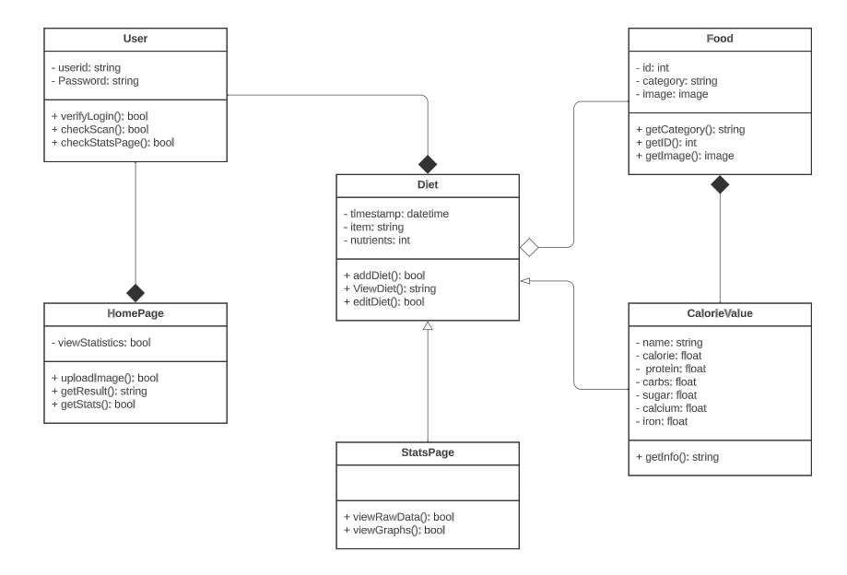

**Sequence Diagram**

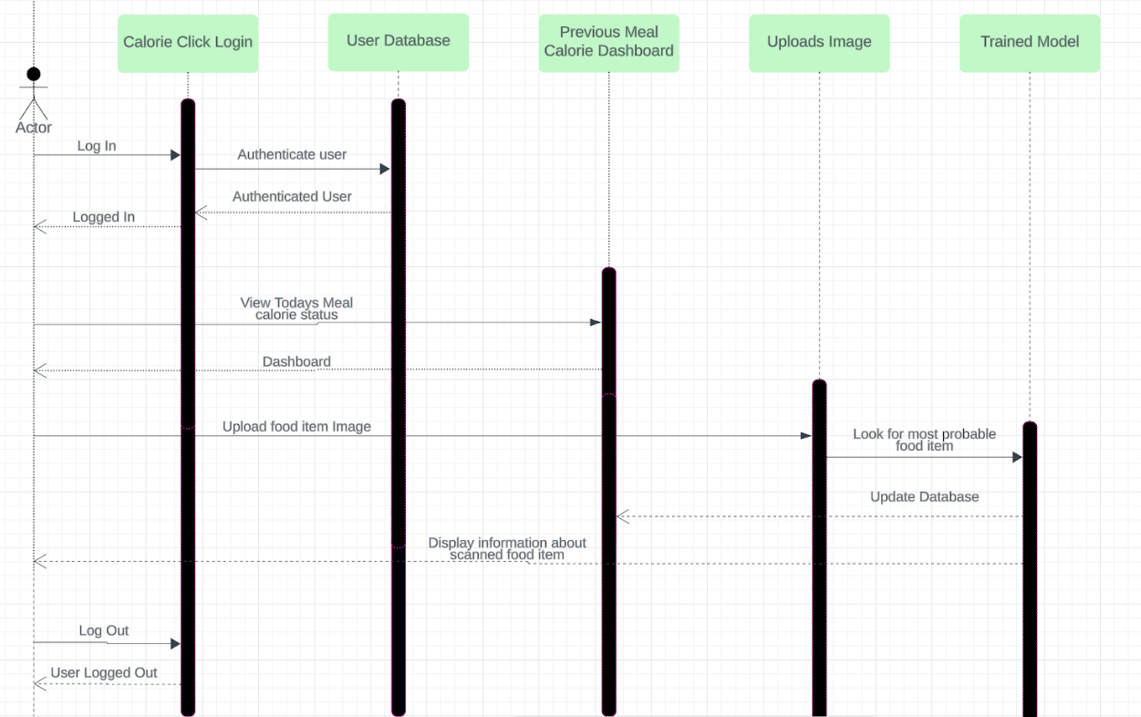

**Collaboration Diagram**

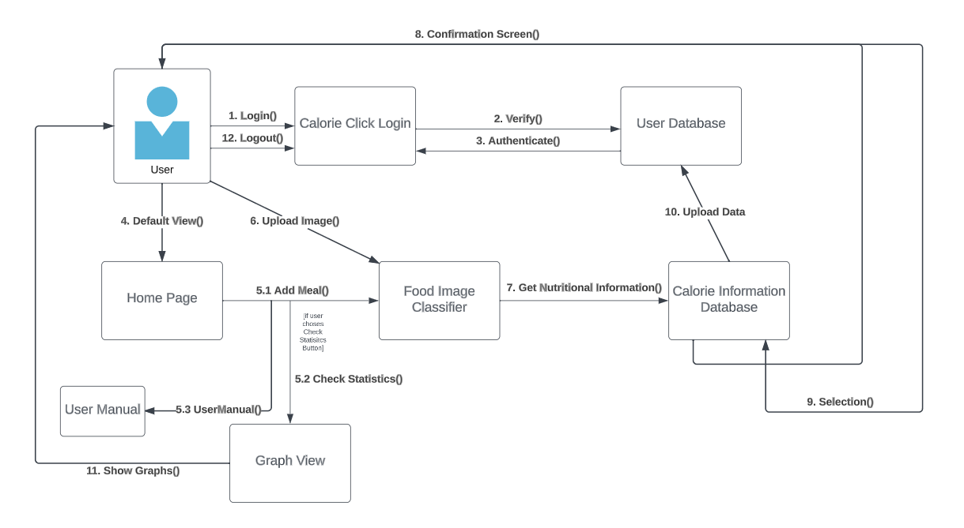

**State Chart Diagram**

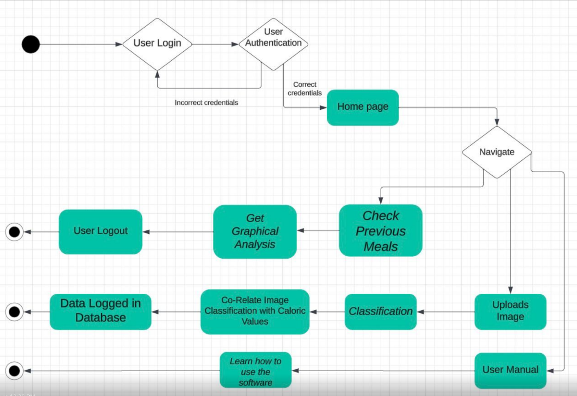

**Component Diagram**

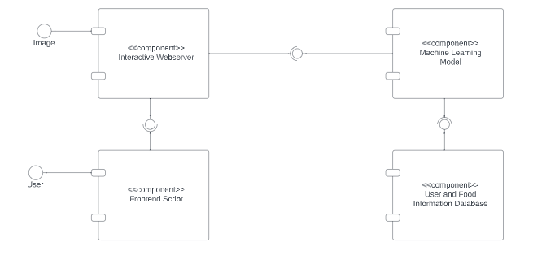

**Deployment Diagram**

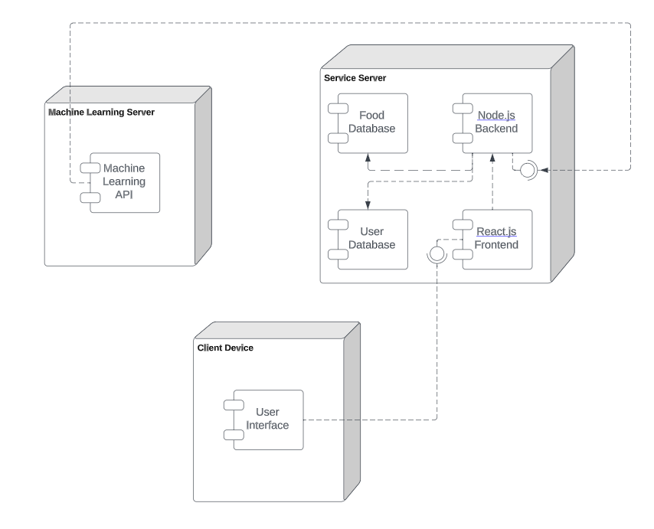**Screenshots of Software**

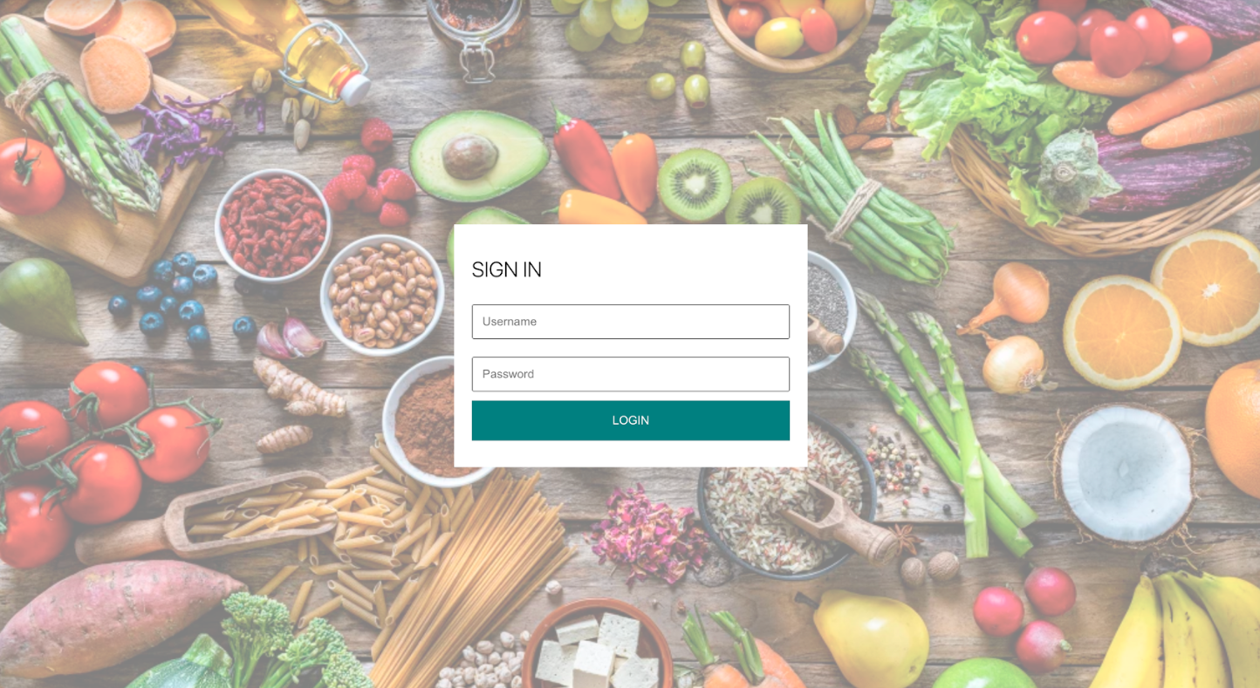

Figure : Login Screen

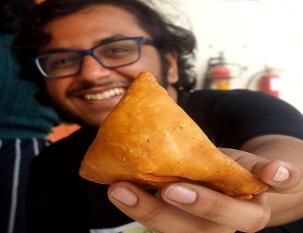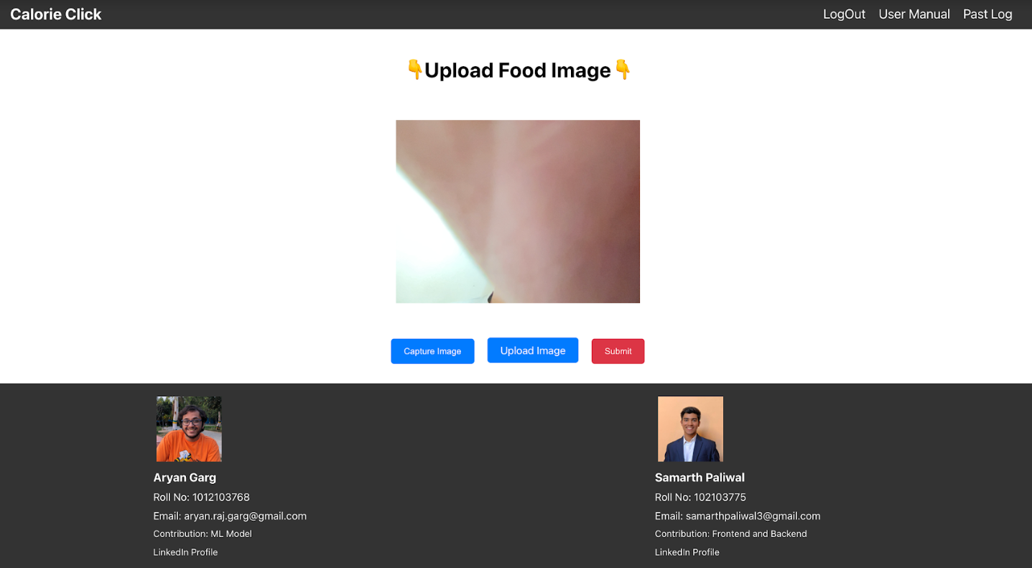

Figure : Front Page

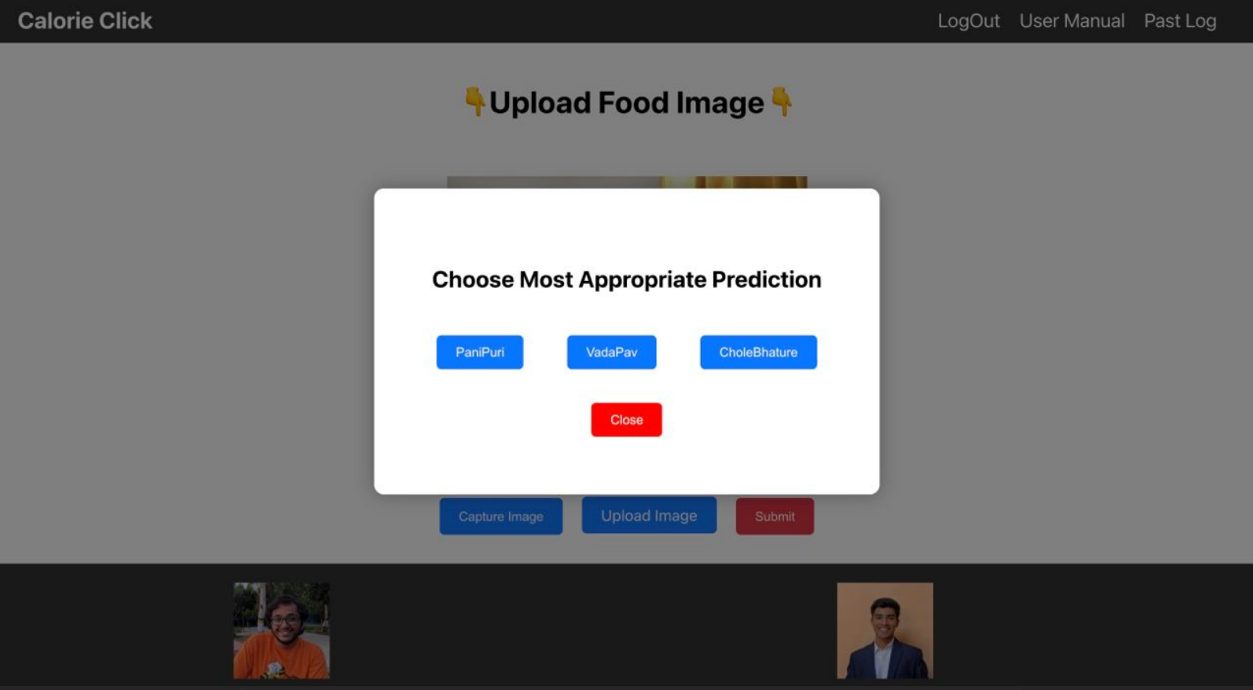

Figure : Selection of Item

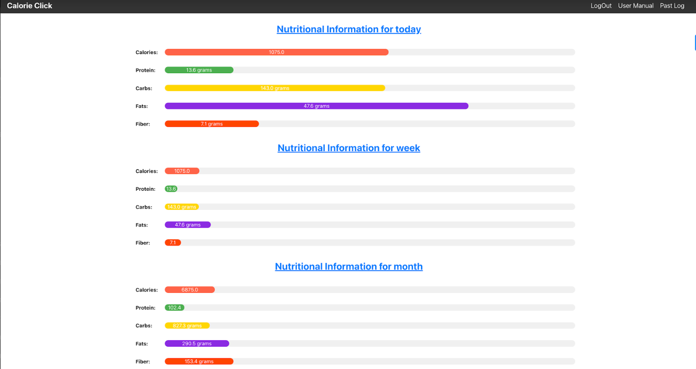

Figure 4: Nutritional Information

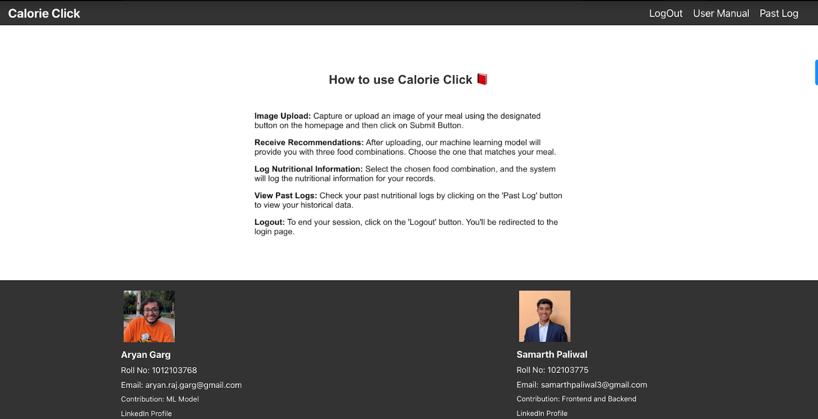

Figure 5: User Manual

**Test Cases**

|  |  |  |
| --- | --- | --- |
| Test Case # 1 | Test Case Name: User Login | Page:  1 of 10 |
| System: Calorie Click | Subsystem: Authentication |  |
| Designed By:Samarth Paliwal | Design Date:17 Nov 2023 |  |
| Executed By: Aryan Garg | Execution Date: 17 Nov 2023 | |
| Short Description: User try to login to the software | |  |

|  |
| --- |
| **Pre-Conditions:**   * The user has a registered account on Calorie Click. |

|  |  |  |  |  |
| --- | --- | --- | --- | --- |
| Step | Action | Expected System Response | Pass/Fail | Comment |
| 1. | Enter username | NA | Pass |  |
| 2. | Enter Password | NA | Pass |  |
| 3. | Click on “Login” button | Credentials are cross checked with Database. | Pass | Works |

|  |
| --- |
| **Post-Conditions**   * The user is either redirected to the home page upon successful login or remains on the login page with an error message. |

|  |  |  |
| --- | --- | --- |
| Test Case # 2 | Test Case Name: Web Cam Access | Page 2 of 10 |
| System: Calorie Click | Subsystem: Website |  |
| Designed By:Samarth Paliwal | Design Date: 17 Nov 2023 |  |
| Executed By: Aryan Garg | Execution Date: 17 Nov 2023 | |
| Short Description: Webcam Access Permission Prompt on Home Screen | |  |

|  |
| --- |
| **Pre-Conditions:**   * The user is successfully logged into the Calorie Click. * The device has a webcam. |

|  |  |  |  |  |
| --- | --- | --- | --- | --- |
| Step | Action | Expected System Response | Pass/Fail | Comment |
| 1. | Navigate to Home page | Displays a prompt requesting access to the webcam. | Pass |  |
| 2. | Confirm Webcam Access | The system detects and confirms that webcam access has been granted. | Pass |  |
| 3. | Deny Webcam Access | The system handles denied access successfully, displaying a white screen in the preview area. | Pass | Works |

|  |
| --- |
| **Post-Conditions**   * The user has either granted or denied webcam access on the home screen. |

|  |  |  |
| --- | --- | --- |
| Test Case # 3 | Test Case Name: User Manual | Page  3 of 10 |
| System: Calorie-Click | Subsystem: Website |  |
| Designed By:Samarth Paliwal | Design Date:17 Nov 2023 |  |
| Executed By: Aryan Garg | Execution Date: 17 Nov 2023 | |
| Short Description: User can get information about the nutrients being tracked | | |

|  |
| --- |
| **Pre-Conditions:**   * The user is successfully logged into the Calorie Click. |

|  |  |  |  |  |
| --- | --- | --- | --- | --- |
| Step | Action | Expected System Response | Pass/Fail | Comment |
| 1. | Click on ‘User Manual’ button | System will navigate the user to Instruction page where user can see how to use the software. | Pass | Works |

|  |
| --- |
| **Post-Conditions**   * The user has accessed the User Manual and gained insights into how to use the software effectively. |

|  |  |  |  |
| --- | --- | --- | --- |
| Test Case # 4 | Test Case Name: Upload Meal | Page  4 of 10 | |
| System: Cookie-Click | Subsystem: Model | |  |
| Designed By: Aryan Garg | Design Date: 17/11/2023 | |  |
| Executed By: Samarth Paliwal | Execution Date: 17/11/2023 | |  |
| Short Description: Upload Image of Meal in Browser | | |  |

|  |
| --- |
| **Pre-Conditions**   * User Logged in * User has Image stored on device * User is on Home Page |

|  |  |  |  |  |
| --- | --- | --- | --- | --- |
| Step | Action | Expected System Response | Pass/Fail | Comment |
| 1 | Click Upload Image Button | Upload Dialog Appear | Pass |  |
| 2 | Upload from Storage | Get Image from Storage | Pass |  |
| 3 | Click Submit Button | Process Image | Pass | Works |

|  |
| --- |
| **Post-Conditions**   * Image is sent to be processed |

|  |  |  |  |
| --- | --- | --- | --- |
| Test Case # 5 | Test Case Name: Capture Meal | Page  5 of 10 | |
| System: Cookie-Click | Subsystem: Model | |  |
| Designed By: Aryan Garg | Design Date: 17/11/2023 | |  |
| Executed By: Samarth Paliwal | Execution Date: 17/11/2023 | |  |
| Short Description: Capture an Image of Food from the Browser | | |  |

|  |
| --- |
| **Pre-Conditions**   * User Logged in * User has camera on Device * User has Camera permission enabled * User is on Home Page |

|  |  |  |  |  |
| --- | --- | --- | --- | --- |
| Step | Action | Expected System Response | Pass/Fail | Comment |
| 1 | Click Capture Image | Image is captured | Pass |  |
| 2 | Click Submit Button | Process Image | Pass |  |

|  |
| --- |
| **Post-Conditions**   * Image is sent to be processed |

|  |  |  |  |
| --- | --- | --- | --- |
| Test Case # 6 | Test Case Name: Model Response | Page  6 of 10 | |
| System: Cookie-Click | Subsystem: Model | |  |
| Designed By: Aryan Garg | Design Date: 17/11/2023 | |  |
| Executed By: Samarth Paliwal | Execution Date: 17/11/2023 | |  |
| Short Description: Upload Image to server and then get output | | |  |

|  |
| --- |
| **Pre-Conditions**   * User Logged in * User has uploaded Image for Processing |

|  |  |  |  |  |
| --- | --- | --- | --- | --- |
| Step | Action | Expected System Response | Pass/Fail | Comment |
| 1 | Image is Processed | Convert to Base64 Image | Pass |  |
| 2 | Sent to Model | API Call | Pass |  |
| 3 | Return Result | Get 3 options or cancel | Pass |  |
| 4 | User Select Button | Option is chosen from 3 | Pass |  |
| 5 | Click Save Button | Option is saved to Backend | Pass | Works |

|  |
| --- |
| **Post-Conditions**   * New Food Entry is entered in the Database |

|  |  |  |  |
| --- | --- | --- | --- |
| Test Case # 7 | Test Case Name: Cancel Selection | Page  7 of 10 | |
| System: Cookie-Click | Subsystem: Model | |  |
| Designed By: Aryan Garg | Design Date: 17/11/2023 | |  |
| Executed By: Samarth Paliwal | Execution Date: 17/11/2023 | |  |
| Short Description: Remove selection after image is sent to server | | |  |

|  |
| --- |
| **Pre-Conditions**   * User Logged in * User has uploaded Image for Processing |

|  |  |  |  |  |
| --- | --- | --- | --- | --- |
| Step | Action | Expected System Response | Pass/Fail | Comment |
| 1 | Return Result | Get 3 options or cancel | Pass |  |
| 2 | User Select Button | Cancel Option is Selected | Pass |  |
| 3 | Cancel Button | Decision is Discarded | Pass | Works |

|  |
| --- |
| **Post-Conditions**   * Option is Discarded |

|  |  |  |
| --- | --- | --- |
| Test Case # 8 | Test Case Name: Past Nutrients Intake | Page  8 of 10 |
| System: Calorie Click | Subsystem: Statistics |  |
| Designed By:Samarth Paliwal | Design Date:17 Nov 2023 |  |
| Executed By: Aryan Garg | Execution Date: 17 Nov 2023 | |
| Short Description: Reviewing past nutrient intake information. | |  |

|  |
| --- |
| **Pre-Conditions:**   * The user is successfully logged into the Calorie Click. |

|  |  |  |  |  |
| --- | --- | --- | --- | --- |
| Step | Action | Expected System Response | Pass/Fail | Comment |
| 1. | Click on 'Past Log' button | System displays the Past Log page, fetching past food intake from Database. | Pass | Works |

|  |
| --- |
| **Post-Conditions**   * The user can view a summary of their past nutrient information of present date, week and month based on the food intake. |

|  |  |  |  |
| --- | --- | --- | --- |
| Test Case # 9 | Test Case Name: Check Food | Page  9 of 10 | |
| System: Cookie-Click | Subsystem: Website | |  |
| Designed By: Aryan Garg | Design Date: 17/11/2023 | |  |
| Executed By: Samarth Paliwal | Execution Date: 17/11/2023 | |  |
| Short Description: Get the name of Meals eaten in the day/Week | | |  |

|  |
| --- |
| **Pre-Conditions**   * User Logged in |

|  |  |  |  |  |
| --- | --- | --- | --- | --- |
| Step | Action | Expected System Response | Pass/Fail | Comment |
| 1 | Click on the Past Log Button | User is taken to Past Logs | Pass |  |
| 2 | Scroll to Past Meal Information | Meal Information with Names | Fail | Partial Working |

|  |
| --- |
| **Post-Conditions**   * User is taken to the home page |

|  |  |  |
| --- | --- | --- |
| Test Case #10 | Test Case Name: Logout | Page  10 of 10 |
| System: Calorie Click | Subsystem: Authenticate |  |
| Designed By:Samarth Paliwal | Design Date:17 Nov 2023 |  |
| Executed By: Aryan Garg | Execution Date: 17 Nov 2023 | |
| Short Description: "Logout" button successfully logs out the user | |  |

|  |
| --- |
| **Pre-Conditions:**   * The user is successfully logged out into the Calorie Click. |

|  |  |  |  |  |
| --- | --- | --- | --- | --- |
| Step | Action | Expected System Response | Pass/Fail | Comment |
| 1. | Click on the "Logout" button. | Redux store set the currentUser to NULL. | Pass | Works |

|  |
| --- |
| **Post-Conditions**   * The user is logged out and redirected to the login page. |